Yokerburn Nursery Uniform Available!

Polo Shirts, T-Shirts & Fleeces available now!
Visit www.myclothing.com & select Yokerburn Nursery to place an order

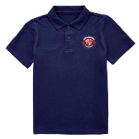
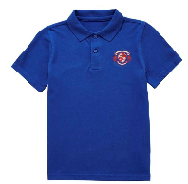
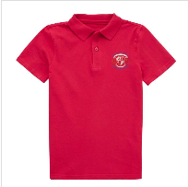
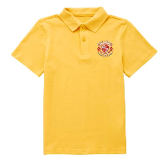

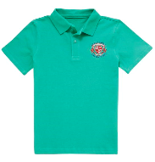
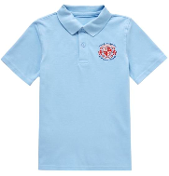
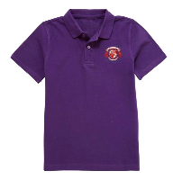
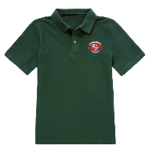

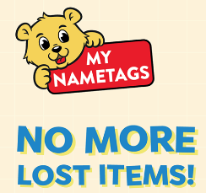

Use the link below to order name labels for your child’s clothing and personal items.
Order online, by going to www.MyNametags.com using the School ID 108839 (please insert our school ID at the checkout page/delivery address)

